SAP EWM – RF Screen Framework

Case1: Create and confirm Warehouse task for the movement of HU to Final Bin.

Below shown are the custom added in the standard RF screen menu:

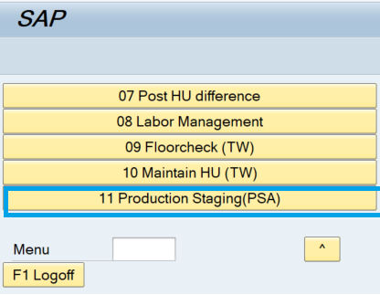     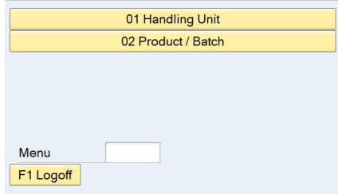

Below explained are the configurations done to add above custom options:

RF Menu Manager

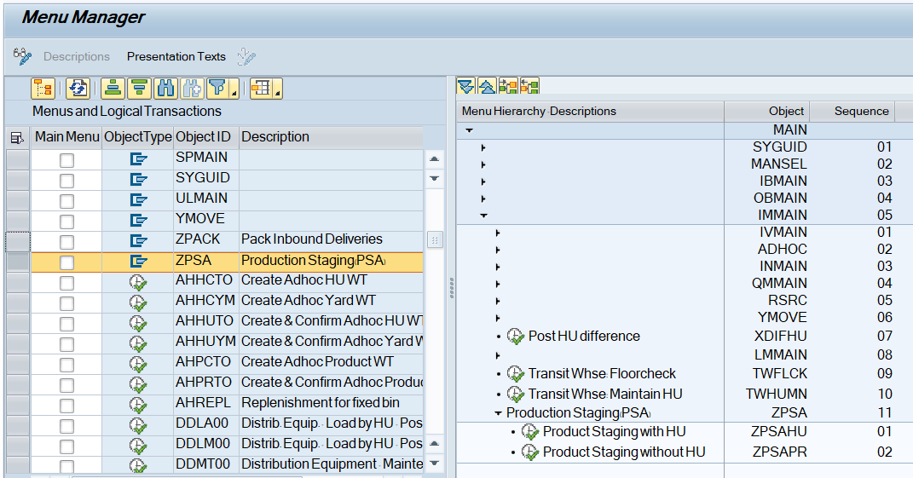

Define Steps in Logical Transactions

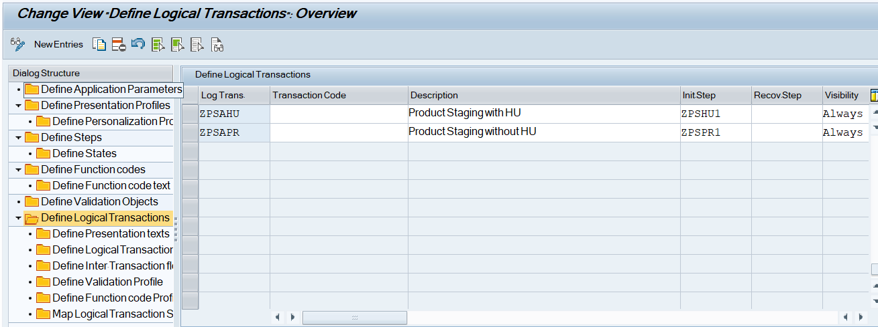

Logical Transaction: ZPSAHU

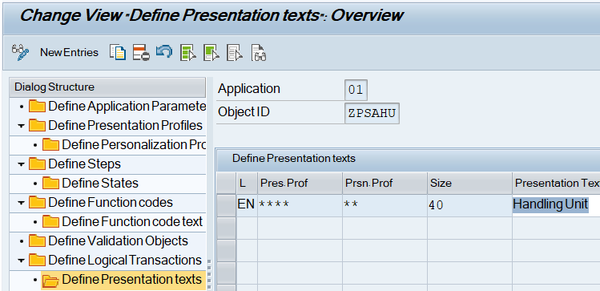

Define Logical Transaction step flow

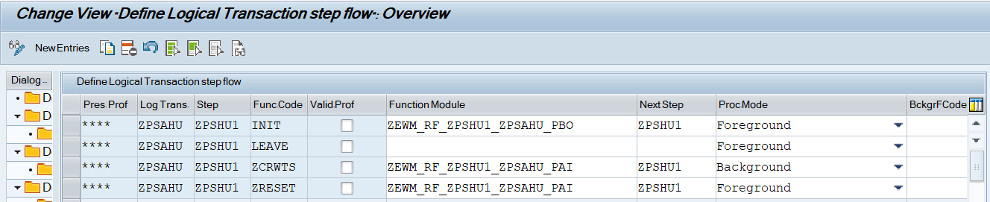

Define Function code Profile.

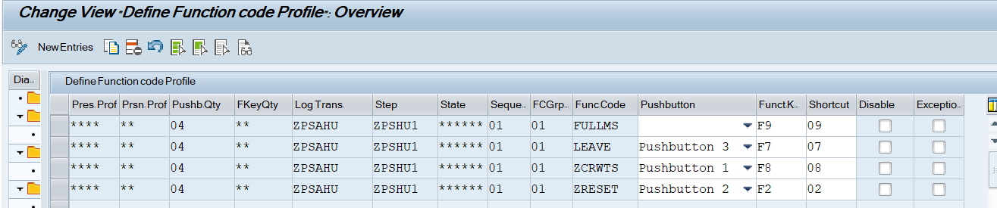

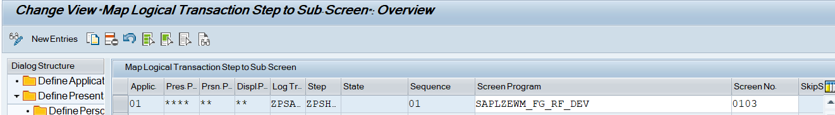

RF Configuration:

--------------------------------------------------------------------------------------------------

Logical Transaction: ZPSAHU

Initial Step: ZPSHU1

Screen Parameters Structure: ZEWM_S_ZPSHU1

FM:

ZEWM_RF_ZPSHU1_ZPSAHU_PBO

ZEWM_RF_ZPSHU1_ZPSAHU_PAI

Function Codes:

ZCRWTS      Create Warehouse Task

--------------------------------------------------------------------------------------------------

Define Steps

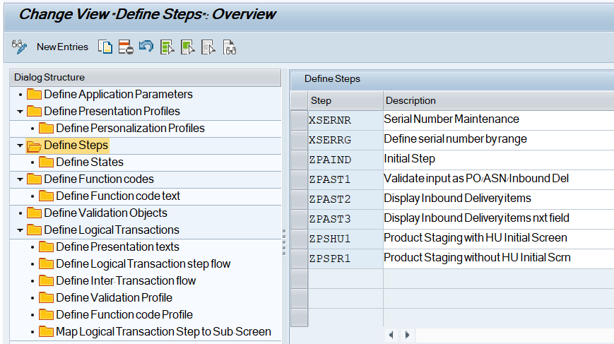

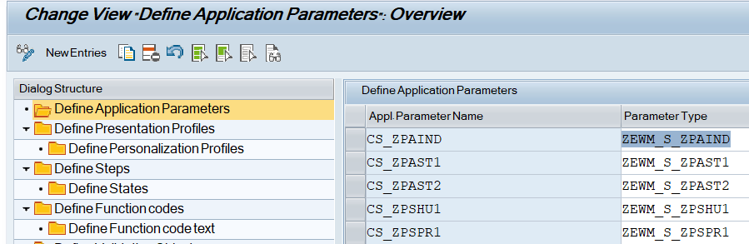

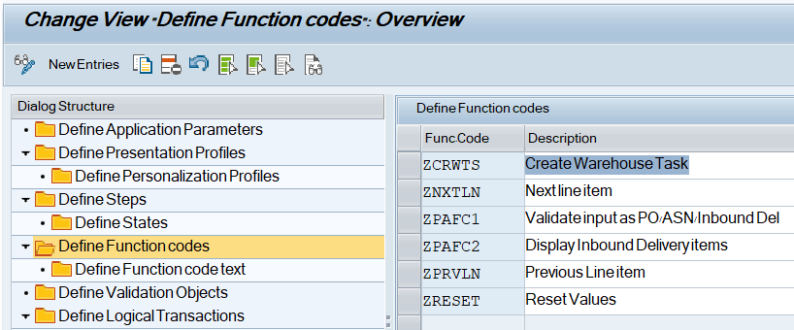

-----------------------------------------------------------------------------------------------------------------------------------------------------------------------------

FUNCTION zewm_rf_zpshu1_zpsahu_pbo.  
*"----------------------------------------------------------------------  
*"*"Local Interface:  
*"  CHANGING  
*"     REFERENCE(CS_ZPSHU1) TYPE  ZEWM_S_ZPSHU1  
*"----------------------------------------------------------------------  
  
*Set screen parameters  
  CALL METHOD /scwm/cl_rf_bll_srvc=>init_screen_param.  
  
  CALL METHOD /scwm/cl_rf_bll_srvc=>set_screen_param  
    EXPORTING  
      iv_param_name = gc_param_cs_zpshu1.  
  
ENDFUNCTION.

-----------------------------------------------------------------------------------------------------------------------------------------------------------------------------

-----------------------------------------------------------------------------------------------------------------------------------------------------------------------------

FUNCTION zewm_rf_zpshu1_zpsahu_pai.  
*"----------------------------------------------------------------------  
*"*"Local Interface:  
*"  CHANGING  
*"     REFERENCE(CS_ZPSHU1) TYPE  ZEWM_S_ZPSHU1  
*"----------------------------------------------------------------------  
  
  DATA:lv_wtcode   TYPE /scwm/de_wtcode,  
       lv_tanum    TYPE /scwm/tanum,  
       lv_severity TYPE bapi_mtype,  
       lv_ok       TYPE xfeld,  
       lv_who      TYPE /scwm/de_who.  
  
  DATA:ls_huhdr    TYPE /scwm/s_huhdr_int,  
       ls_huheader TYPE /scwm/s_huhdr_int,  
       ls_lagp     TYPE /scwm/lagp,  
       ls_rsrc     TYPE /scwm/rsrc,  
       ls_ordim_o  TYPE /scwm/ordim_o.  
  
  DATA:lt_ordim_o   TYPE /scwm/tt_ordim_o,  
       lt_whoid     TYPE /scwm/tt_whoid,  
       lt_who       TYPE /scwm/tt_who_int,  
       lt_create_hu TYPE /scwm/tt_to_crea_hu,  
       lt_ltap_vb   TYPE /scwm/tt_ltap_vb,  
       lt_conf      TYPE /scwm/to_conf_tt,  
       lt_conf_exc  TYPE /scwm/tt_conf_exc,  
       lt_bapiret   TYPE bapiret2_t.  
  
  DATA:lo_hu TYPE REF TO /scwm/cl_wm_packing.  
  
  DATA(lv_fcode) = /scwm/cl_rf_bll_srvc=>get_fcode( ).  
  
  CASE lv_fcode.  
    WHEN 'ZCRWTS'.  
  
      CALL FUNCTION '/SCWM/RSRC_RESOURCE_MEMORY'  
        EXPORTING  
          iv_uname = sy-uname  
        CHANGING  
          cs_rsrc  = ls_rsrc.  
  
      /scwm/cl_rf_bll_srvc=>set_lgnum( iv_lgnum = ls_rsrc-lgnum ).  
  
*--------------------------------------------------------------------  
*Validate if HU exists against the supplier provided HU ID  
*Validate if multiple HU found against the supplier provided HU ID  
*--------------------------------------------------------------------  
      IF cs_zpshu1-hu_id IS NOT INITIAL.  
  
        SELECT a~guid_hu,  
               a~huident AS huid_ext,  
               b~huident AS huid_int  
        FROM /scwm/hu_ident AS a INNER JOIN /scwm/huhdr AS b ON b~guid_hu EQ a~guid_hu  
        INTO TABLE @DATA(lt_huid)  
        WHERE a~huident EQ @cs_zpshu1-hu_id.  
        IF sy-subrc EQ 0.  
          IF lines( lt_huid ) GT 1.  
            MESSAGE e015(zewm01) WITH cs_zpshu1-hu_id.  
          ENDIF.  
        ELSE.  
          MESSAGE e014(zewm01) WITH cs_zpshu1-hu_id.  
        ENDIF.  
      ENDIF.  
*--------------------------------------------------------------------  
  
*--------------------------------------------------------------------  
*Validate WO exists with in process status for HU  
*--------------------------------------------------------------------  
      DATA(lv_huid) = lt_huid[ 1 ]-huid_int.  
  
      CALL FUNCTION '/SCWM/TO_READ_HU'  
        EXPORTING  
          iv_lgnum       = /scwm/cl_rf_bll_srvc=>get_lgnum( )  
          iv_huident     = lv_huid  
        IMPORTING  
          et_ordim_o_src = lt_ordim_o  
        EXCEPTIONS  
          OTHERS         = 0.  
      IF sy-subrc <> 0.  
        MESSAGE ID sy-msgid TYPE sy-msgty NUMBER sy-msgno WITH sy-msgv1 sy-msgv2 sy-msgv3 sy-msgv4.  
      ENDIF.  
  
      LOOP AT lt_ordim_o ASSIGNING FIELD-SYMBOL(<lfs_ordim_o>).  
        APPEND INITIAL LINE TO lt_whoid ASSIGNING FIELD-SYMBOL(<lfs_whoid>).  
        IF <lfs_whoid> IS ASSIGNED.  
          <lfs_whoid>-who = <lfs_ordim_o>-who.  
        ENDIF.  
      ENDLOOP.  
  
      IF lt_whoid IS NOT INITIAL.  
        TRY.  
            CALL FUNCTION '/SCWM/WHO_SELECT'  
              EXPORTING  
                iv_lgnum = /scwm/cl_rf_bll_srvc=>get_lgnum( )  
                it_who   = lt_whoid  
              IMPORTING  
                et_who   = lt_who.  
          CATCH /scwm/cx_core.  
            MESSAGE ID sy-msgid TYPE sy-msgty NUMBER sy-msgno WITH sy-msgv1 sy-msgv2 sy-msgv3 sy-msgv4.  
        ENDTRY.  
  
        LOOP AT lt_who ASSIGNING FIELD-SYMBOL(<ls_who>) WHERE rsrc IS NOT INITIAL.  
          MESSAGE e016(zewm01) WITH lv_huid <ls_who>-rsrc.  
        ENDLOOP.  
  
      ENDIF.  
*--------------------------------------------------------------------  
  
*--------------------------------------------------------------------  
*Validate if source bin is blocked  
*--------------------------------------------------------------------  
  
      CALL FUNCTION '/SCWM/HU_READ'  
        EXPORTING  
          iv_huident = lv_huid  
          iv_lgnum   = /scwm/cl_rf_bll_srvc=>get_lgnum( )  
        IMPORTING  
          es_huhdr   = ls_huhdr  
        EXCEPTIONS  
          error      = 1  
          OTHERS     = 2.  
      IF sy-subrc <> 0.  
        MESSAGE ID sy-msgid TYPE sy-msgty NUMBER sy-msgno WITH sy-msgv1 sy-msgv2 sy-msgv3 sy-msgv4.  
      ENDIF.  
  
      IF ls_huhdr-lgpla IS NOT INITIAL.  
        CALL FUNCTION '/SCWM/LAGP_READ_SINGLE'  
          EXPORTING  
            iv_lgnum      = ls_huhdr-lgnum  
            iv_lgpla      = ls_huhdr-lgpla  
          IMPORTING  
            es_lagp       = ls_lagp  
          EXCEPTIONS  
            wrong_input   = 1  
            not_found     = 2  
            enqueue_error = 3  
            OTHERS        = 4.  
        IF sy-subrc <> 0.  
          MESSAGE ID sy-msgid TYPE sy-msgty NUMBER sy-msgno WITH sy-msgv1 sy-msgv2 sy-msgv3 sy-msgv4.  
        ENDIF.  
      ENDIF.  
  
      IF ls_lagp-skzua = abap_true.  
        MESSAGE e017(zewm01) WITH ls_lagp-lgpla.  
      ENDIF.  
  
*--------------------------------------------------------------------  
  
*--------------------------------------------------------------------  
*Read storage bin configuration  
*--------------------------------------------------------------------  
      SELECT SINGLE *  
      FROM zewm_t_bin_conf  
      INTO @DATA(ls_bin_conf)  
      WHERE warehouse_no EQ @ls_rsrc-lgnum.  
      IF sy-subrc EQ 0.  
  
        IF ls_bin_conf-dest_bin IS INITIAL.  
          MESSAGE e029(zewm01) WITH ls_rsrc-lgnum.  
        ENDIF.  
  
        IF ls_bin_conf-process_type IS INITIAL.  
          MESSAGE e030(zewm01) WITH ls_rsrc-lgnum.  
        ENDIF.  
  
        DATA(lv_dest_bin)     = ls_bin_conf-dest_bin.  
        DATA(lv_process_type) = ls_bin_conf-process_type.  
      ELSE.  
        MESSAGE e029(zewm01) WITH ls_rsrc-lgnum.  
      ENDIF.  
*--------------------------------------------------------------------  
  
*--------------------------------------------------------------------  
*Create Warehouse task for HU movement to Final Bin  
*--------------------------------------------------------------------  
      lv_wtcode = wmegc_wtcode_adhoc_hu.  
  
      lo_hu = NEW #( ).  
  
      CALL METHOD lo_hu->get_hu  
        EXPORTING  
          iv_guid_hu = lt_huid[ 1 ]-guid_hu  
          iv_lock    = 'X'  
        IMPORTING  
          es_huhdr   = ls_huheader  
        EXCEPTIONS  
          not_found  = 1  
          OTHERS     = 2.  
      IF sy-subrc <> 0.  
        MESSAGE ID sy-msgid TYPE sy-msgty NUMBER sy-msgno WITH sy-msgv1 sy-msgv2 sy-msgv3 sy-msgv4.  
      ENDIF.  
  
      lt_create_hu = VALUE #( ( huident  = lv_huid  
                                guid_hu = lt_huid[ 1 ]-guid_hu  
                                procty  = lv_process_type  
                                nlpla   = lv_dest_bin  
                                nlenr   = lv_huid  
                                seqno   = 1  
                                dstgrp  = ls_huheader-dstgrp ) ).  
  
      CALL FUNCTION '/SCWM/RF_PRINT_GLOBAL_DATA'.  
  
      CALL FUNCTION '/SCWM/TO_CREATE_MOVE_HU'  
        EXPORTING  
          iv_lgnum       = ls_huhdr-lgnum  
          it_create_hu   = lt_create_hu  
          iv_wtcode      = lv_wtcode  
          iv_commit_work = ' '  
        IMPORTING  
          ev_tanum       = lv_tanum  
          et_ltap_vb     = lt_ltap_vb  
          et_bapiret     = lt_bapiret  
          ev_severity    = lv_severity.  
  
      IF lv_severity CA wmegc_severity_eax.  
        IF lt_bapiret IS NOT INITIAL.  
          LOOP AT lt_bapiret INTO DATA(ls_bapiret).  
            IF ls_bapiret-type CA wmegc_severity_ea.  
              MESSAGE ID ls_bapiret-id TYPE ls_bapiret-type NUMBER ls_bapiret-number WITH ls_bapiret-message_v1  
                                                                                          ls_bapiret-message_v2  
                                                                                          ls_bapiret-message_v3  
                                                                                          ls_bapiret-message_v4.  
              EXIT.  
            ENDIF.  
          ENDLOOP.  
        ENDIF.  
      ENDIF.  
  
      COMMIT WORK AND WAIT.  
      IF sy-subrc IS NOT INITIAL.  
        MESSAGE e018(zewm01).  
      ENDIF.  
  
*--------------------------------------------------------------------  
*Validate if warehouse order designed for resource  
*--------------------------------------------------------------------  
      IF line_exists( lt_ltap_vb[ tanum = lv_tanum ] ).  
        DATA(ls_ltap_vb) = lt_ltap_vb[ tanum = lv_tanum ].  
  
        PERFORM who_rsrc_allowed USING ls_huhdr-lgnum  
                                       ls_ltap_vb-who  
                                       ls_ltap_vb-queue  
                                 CHANGING lv_ok.  
  
        IF lv_ok IS INITIAL.  
          MESSAGE e019(zewm01).  
        ENDIF.  
      ENDIF.  
  
      CALL FUNCTION '/SCWM/REC_WT_CHANGE'  
        EXPORTING  
          it_ltap_vb        = lt_ltap_vb  
        EXCEPTIONS  
          no_free_wt_in_who = 1  
          internal_error    = 2  
          OTHERS            = 3.  
      IF sy-subrc <> 0.  
        MESSAGE ID sy-msgid TYPE sy-msgty NUMBER sy-msgno WITH sy-msgv1 sy-msgv2 sy-msgv3 sy-msgv4.  
      ENDIF.  
  
*--------------------------------------------------------------------  
*Confirm Warehouse Task  
*--------------------------------------------------------------------  
  
*Update WHO with resource and processor and start bin  
      lv_who = ls_ltap_vb-who.  
      CALL FUNCTION '/SCWM/RF_WHO_UPD'  
        EXPORTING  
          iv_lgnum = ls_huhdr-lgnum  
          iv_who   = lv_who.  
  
      CLEAR:lt_bapiret,lv_severity.  
  
      CALL FUNCTION '/SCWM/RSRC_RESOURCE_MEMORY'  
        EXPORTING  
          iv_uname = sy-uname  
        CHANGING  
          cs_rsrc  = ls_rsrc.  
  
      APPEND INITIAL LINE TO lt_conf ASSIGNING FIELD-SYMBOL(<lfs_conf>).  
      IF <lfs_conf> IS ASSIGNED.  
        <lfs_conf>-tanum = lv_tanum.  
        <lfs_conf>-squit = abap_true.  
        <lfs_conf>-nlenr = lv_huid.  
  
        CALL FUNCTION 'CONVERSION_EXIT_HUID_INPUT'  
          EXPORTING  
            input  = <lfs_conf>-nlenr  
          IMPORTING  
            output = <lfs_conf>-nlenr.  
  
        <lfs_conf>-drsrc = ls_rsrc-rsrc.  
      ENDIF.  
  
      CALL FUNCTION '/SCWM/TO_CONFIRM'  
        EXPORTING  
          iv_lgnum         = ls_huhdr-lgnum  
          iv_wtcode        = wmegc_wtcode_rsrc  
          it_conf          = lt_conf  
          iv_commit_work   = ' '  
          iv_update_task   = ' '  
          iv_processor_det = 'X'  
        IMPORTING  
          et_bapiret       = lt_bapiret  
          ev_severity      = lv_severity.  
  
      IF lv_severity CA wmegc_severity_eax.  
        LOOP AT lt_bapiret INTO ls_bapiret.  
          IF ls_bapiret-type CA wmegc_severity_ea.  
            MESSAGE ID ls_bapiret-id TYPE ls_bapiret-type NUMBER ls_bapiret-number WITH ls_bapiret-message_v1  
                                                                                        ls_bapiret-message_v2  
                                                                                        ls_bapiret-message_v3  
                                                                                        ls_bapiret-message_v4.  
            EXIT.  
          ENDIF.  
        ENDLOOP.  
      ENDIF.  
  
      COMMIT WORK AND WAIT.  
      IF sy-subrc IS NOT INITIAL.  
        MESSAGE e020(zewm01).  
      ENDIF.  
  
*Determination of new TO number  
      CLEAR lt_ordim_o.  
      CALL FUNCTION '/SCWM/TO_READ_WHO'  
        EXPORTING  
          iv_lgnum     = ls_huhdr-lgnum  
          iv_who       = lv_who  
        IMPORTING  
          et_ordim_o   = lt_ordim_o  
        EXCEPTIONS  
          wrong_input  = 1  
          not_found    = 2  
          foreign_lock = 3  
          error        = 4  
          OTHERS       = 5.  
      IF sy-subrc <> 0.  
        MESSAGE ID sy-msgid TYPE sy-msgty NUMBER sy-msgno WITH sy-msgv1 sy-msgv2 sy-msgv3 sy-msgv4.  
      ENDIF.  
  
      IF lt_ordim_o IS NOT INITIAL.  
  
        IF line_exists( lt_ordim_o[ who = lv_who ] ).  
          ls_ordim_o = lt_ordim_o[ who = lv_who ].  
        ENDIF.  
  
        CALL FUNCTION '/SCWM/REC_WT_CHANGE'  
          EXPORTING  
            it_ltap_vb        = lt_ltap_vb  
          CHANGING  
            cs_ordim_o        = ls_ordim_o  
            ct_ordim_o        = lt_ordim_o  
          EXCEPTIONS  
            no_free_wt_in_who = 1  
            internal_error    = 2  
            OTHERS            = 3.  
        IF sy-subrc <> 0.  
          MESSAGE ID sy-msgid TYPE sy-msgty NUMBER sy-msgno WITH sy-msgv1 sy-msgv2 sy-msgv3 sy-msgv4.  
        ENDIF.  
      ENDIF.  
  
*--------------------------------------------------------------------  
*Confirm new TO on destination bin  
*--------------------------------------------------------------------  
      CLEAR lt_conf.  
      APPEND INITIAL LINE TO lt_conf ASSIGNING <lfs_conf>.  
      IF <lfs_conf> IS ASSIGNED.  
        <lfs_conf>-tanum = lv_tanum.  
        <lfs_conf>-nlpla = lv_dest_bin.  
        <lfs_conf>-nlenr = lv_huid.  
  
        CALL FUNCTION 'CONVERSION_EXIT_HUID_INPUT'  
          EXPORTING  
            input  = <lfs_conf>-nlenr  
          IMPORTING  
            output = <lfs_conf>-nlenr.  
      ENDIF.  
  
      CLEAR:lv_severity,lt_bapiret.  
      CALL FUNCTION '/SCWM/TO_CONF_INT_SIMULATE'  
        EXPORTING  
          iv_lgnum                 = ls_huhdr-lgnum  
          iv_catch_weight_no_check = abap_true  
          it_conf                  = lt_conf  
          it_conf_exc              = lt_conf_exc  
        IMPORTING  
          et_ltap_vb               = lt_ltap_vb  
          et_bapiret               = lt_bapiret  
          ev_severity              = lv_severity  
          ev_ok                    = lv_ok.  
  
      IF lv_severity CA 'EAX'.  
        CLEAR ls_bapiret.  
        LOOP AT lt_bapiret INTO ls_bapiret.  
          IF ls_bapiret-type CA wmegc_severity_ea.  
            MESSAGE ID ls_bapiret-id TYPE ls_bapiret-type NUMBER ls_bapiret-number WITH ls_bapiret-message_v1  
                                                                                        ls_bapiret-message_v2  
                                                                                        ls_bapiret-message_v3  
                                                                                        ls_bapiret-message_v4.  
            EXIT.  
          ENDIF.  
        ENDLOOP.  
      ENDIF.  
  
      CLEAR:lv_severity,lt_bapiret.  
      CALL FUNCTION '/SCWM/TO_CONFIRM'  
        EXPORTING  
          iv_lgnum         = ls_huhdr-lgnum  
          it_conf          = lt_conf  
          iv_commit_work   = ' '  
          iv_update_task   = ' '  
          iv_processor_det = 'X'  
          it_conf_exc      = lt_conf_exc  
        IMPORTING  
          et_bapiret       = lt_bapiret  
          ev_severity      = lv_severity.  
  
      IF lv_severity CA wmegc_severity_eax.  
        CLEAR ls_bapiret.  
        LOOP AT lt_bapiret INTO ls_bapiret.  
          IF ls_bapiret-type CA wmegc_severity_ea.  
            MESSAGE ID ls_bapiret-id TYPE ls_bapiret-type NUMBER ls_bapiret-number WITH ls_bapiret-message_v1  
                                                                                        ls_bapiret-message_v2  
                                                                                        ls_bapiret-message_v3  
                                                                                        ls_bapiret-message_v4.  
            EXIT.  
          ENDIF.  
        ENDLOOP.  
      ENDIF.  
  
      COMMIT WORK AND WAIT.  
      IF sy-subrc IS NOT INITIAL.  
        MESSAGE e020(zewm01).  
      ENDIF.  
  
      /scwm/cl_rf_bll_srvc=>set_prmod( '1' ).  
      /scwm/cl_rf_bll_srvc=>set_fcode( /scwm/cl_rf_bll_srvc=>c_fcode_compl_ltrans ).  
  
    WHEN 'ZRESET'.  
      CLEAR cs_zpshu1-hu_id.  
  
    WHEN OTHERS.  
  ENDCASE.  
  
ENDFUNCTION.

-----------------------------------------------------------------------------------------------------------------------------------------------------------------------------

Unit test detail:

Prerequisite: Process Type and Destination Bin for the warehouse should be maintained as shown below using SM30 - ZEWM_T_BIN_CONF:

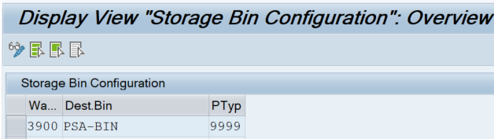

Case 1 : Perform PSA with Supplier provided Handling Unit.

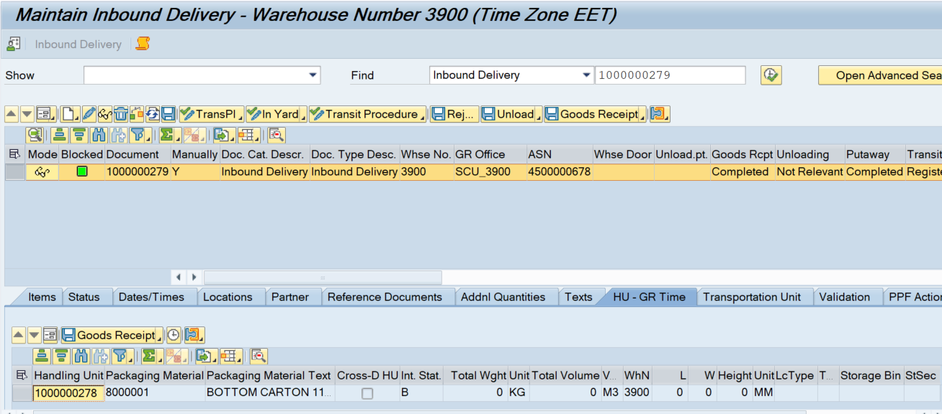

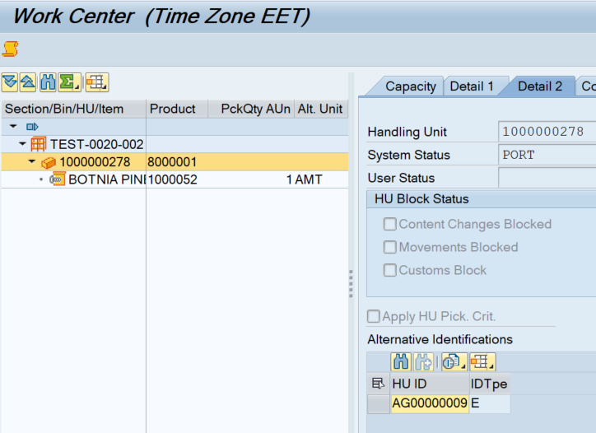

Click on Handling Unit Button and enter supplier provided HU and click on Execute button.

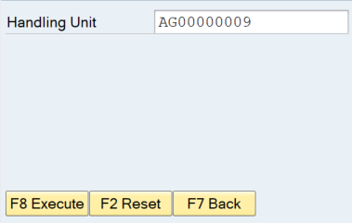

Same as SAP standard behavior, screen flow will come back to initial menu if successful.  
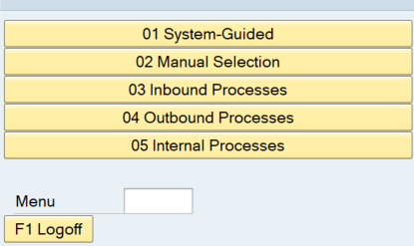

Go to /SCWM/MON transaction code and check the warehouse task for the movement to final bin.

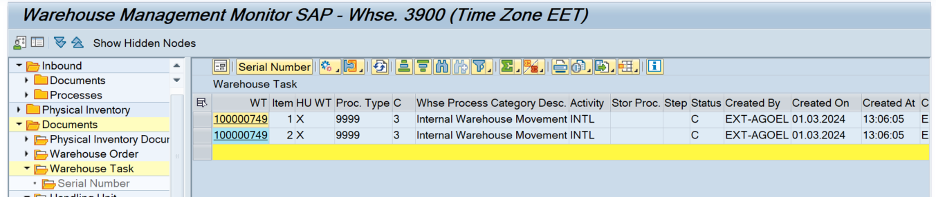

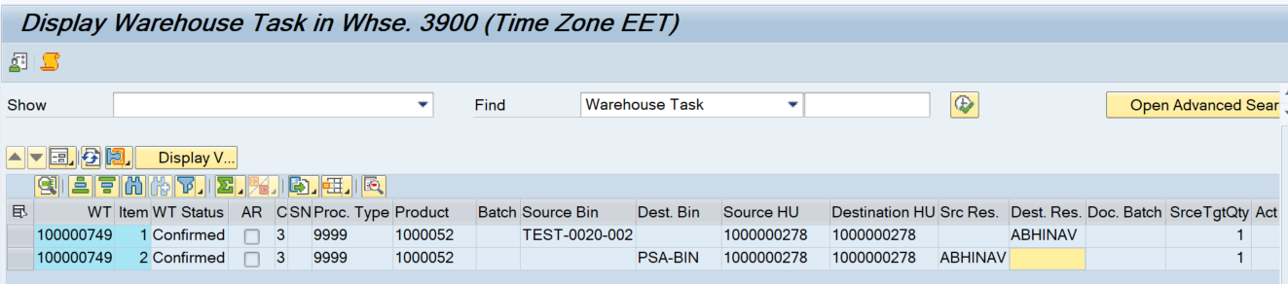

Case 2:Create and confirm Warehouse task for the movement of Product/Batch to Final Bin.

Logical Transaction: ZPSAPR

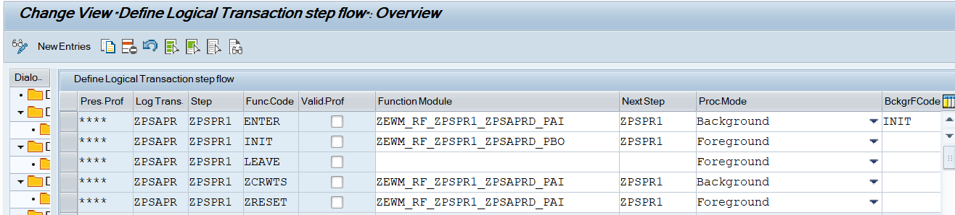

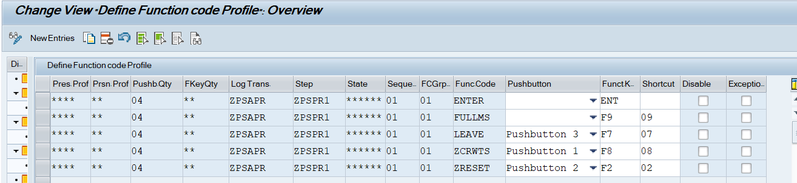

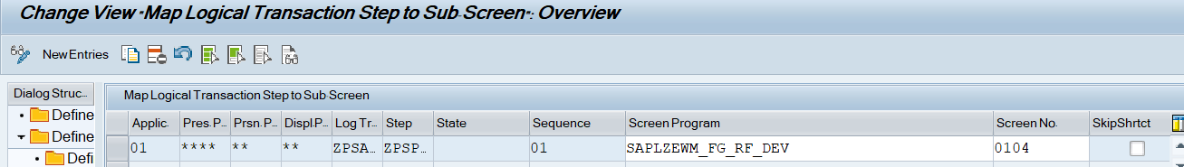

--------------------------------------------------------------------------------------------------------------------------------------------------

FUNCTION zewm_rf_zpspr1_zpsaprd_pbo.  
*"----------------------------------------------------------------------  
*"*"Local Interface:  
*"  CHANGING  
*"     REFERENCE(CS_ZPSPR1) TYPE  ZEWM_S_ZPSPR1  
*"----------------------------------------------------------------------  
  
*Set screen parameters  
  CALL METHOD /scwm/cl_rf_bll_srvc=>init_screen_param.  
  
  CALL METHOD /scwm/cl_rf_bll_srvc=>set_screen_param  
    EXPORTING  
      iv_param_name = gc_param_cs_zpspr1.  
  
ENDFUNCTION.

--------------------------------------------------------------------------------------------------------------------------------------------------

--------------------------------------------------------------------------------------------------------------------------------------------------

FUNCTION zewm_rf_zpspr1_zpsaprd_pai.  
*"----------------------------------------------------------------------  
*"*"Local Interface:  
*"  CHANGING  
*"     REFERENCE(CS_ZPSPR1) TYPE  ZEWM_S_ZPSPR1  
*"----------------------------------------------------------------------  
  
  DATA:lv_matnr40       TYPE /scwm/de_rf_matnr40,  
       lv_filtered_auth TYPE xfeld,  
       lv_matid         TYPE /scwm/de_matid,  
       lv_papos         TYPE /scwm/ltap_hu_papos,  
       lv_severity      TYPE bapi_mtype,  
       lv_ok            TYPE xfeld.  
  
  DATA:ls_rsrc       TYPE /scwm/rsrc,  
       ls_ordim_o    TYPE /scwm/ordim_o,  
       ls_mat_global TYPE /scwm/s_material_global.  
  
  DATA:lt_range_matid TYPE rseloption,  
       lt_range_lgpla TYPE rseloption,  
       lt_range_matnr TYPE rseloption,  
       lt_conf        TYPE /scwm/to_conf_tt,  
       lt_aqua_int    TYPE /scwm/tt_aqua_int2,  
       lt_ordim_c     TYPE /scwm/tt_ordim_c,  
       lt_conf_exc    TYPE /scwm/tt_conf_exc,  
       lt_conf_serid  TYPE /scwm/tt_conf_serid,  
       lt_ltap_vb     TYPE /scwm/tt_ltap_vb,  
       lt_bapiret     TYPE bapiret2_t.  
  
  DATA(lv_fcode) = /scwm/cl_rf_bll_srvc=>get_fcode( ).  
  
  CASE lv_fcode.  
    WHEN 'ENTER'.  
*--------------------------------------------------------  
*Validate manadatory input received  
*--------------------------------------------------------  
      IF cs_zpspr1-product IS INITIAL.  
        MESSAGE e021(zewm01).  
      ENDIF.  
  
      IF cs_zpspr1-source_bin IS INITIAL.  
        MESSAGE e022(zewm01).  
      ENDIF.  
  
      IF gv_batch_req EQ abap_true.  
        IF cs_zpspr1-batch IS INITIAL.  
          MESSAGE e028(zewm01).  
        ENDIF.  
      ENDIF.  
  
*--------------------------------------------------------  
  
      CALL FUNCTION '/SCWM/RSRC_RESOURCE_MEMORY'  
        EXPORTING  
          iv_uname = sy-uname  
        CHANGING  
          cs_rsrc  = ls_rsrc.  
  
*--------------------------------------------------------  
*Validate if product exists  
*--------------------------------------------------------  
      lv_matnr40 = cs_zpspr1-product.  
  
      CALL FUNCTION '/SCWM/RF_PRODUCT_INPUT'  
        EXPORTING  
          input    = lv_matnr40  
        IMPORTING  
          ev_matid = lv_matid.  
  
      IF lv_matid IS INITIAL.  
        MESSAGE e023(zewm01) WITH cs_zpspr1-product.  
      ENDIF.  
*--------------------------------------------------------  
  
*--------------------------------------------------------  
*Validate if the product is batch managed  
*--------------------------------------------------------  
      IF gv_batch_req EQ abap_false.  
  
        TRY.  
            CALL FUNCTION '/SCWM/MATERIAL_READ_SINGLE'  
              EXPORTING  
                iv_matid      = lv_matid  
                iv_lgnum      = ls_rsrc-lgnum  
              IMPORTING  
                es_mat_global = ls_mat_global.  
          CATCH /scwm/cx_md.  
        ENDTRY.  
  
        IF  ls_mat_global-batch_req EQ abap_true.  
          /scwm/cl_rf_bll_srvc=>set_screlm_input_on( 'ZEWM_S_ZPSPR1-BATCH' ).  
          gv_batch_req = abap_true.  
          EXIT.  
        ENDIF.  
  
      ENDIF.  
*--------------------------------------------------------  
  
*--------------------------------------------------------  
*Read data to process  
*--------------------------------------------------------  
      lt_range_lgpla = VALUE #( ( sign   = 'I'  
                                  option = 'EQ'  
                                  low    = cs_zpspr1-source_bin ) ).  
  
      lt_range_matid = VALUE #( ( sign   = 'I'  
                                  option = 'EQ'  
                                  low    = lv_matid ) ).  
  
      CALL FUNCTION '/SCWM/AQUA_SELECT'  
        EXPORTING  
          iv_lgnum         = ls_rsrc-lgnum  
          ir_lgpla         = lt_range_lgpla  
          ir_matid         = lt_range_matid  
        IMPORTING  
          et_aqua_int      = lt_aqua_int  
          ev_filtered_auth = lv_filtered_auth  
        EXCEPTIONS  
          wrong_input      = 1  
          OTHERS           = 2.  
      IF sy-subrc <> 0.  
        MESSAGE ID sy-msgid TYPE sy-msgty NUMBER sy-msgno WITH sy-msgv1 sy-msgv2 sy-msgv3 sy-msgv4.  
      ENDIF.  
  
      IF lv_filtered_auth IS NOT INITIAL.  
        MESSAGE e025(zewm01).  
      ENDIF.  
  
      cs_zpspr1-quantum = lines( lt_aqua_int ).  
      DELETE lt_aqua_int WHERE huident IS NOT INITIAL.  
  
      IF gv_batch_req EQ abap_true.  
        DELETE lt_aqua_int WHERE charg NE cs_zpspr1-batch.  
      ENDIF.  
  
      IF gv_batch_req EQ abap_false.  
        IF line_exists( lt_aqua_int[ lgnum = ls_rsrc-lgnum  
                                     lgpla = cs_zpspr1-source_bin  
                                     matid = lv_matid ] ).  
  
          DATA(ls_aqua_int) = lt_aqua_int[ lgnum = ls_rsrc-lgnum  
                                           lgpla = cs_zpspr1-source_bin  
                                           matid = lv_matid ].  
  
        ENDIF.  
      ELSE.  
        IF line_exists( lt_aqua_int[ lgnum = ls_rsrc-lgnum  
                                     lgpla = cs_zpspr1-source_bin  
                                     matid = lv_matid  
                                     charg = cs_zpspr1-batch ] ).  
  
          ls_aqua_int = lt_aqua_int[ lgnum = ls_rsrc-lgnum  
                                     lgpla = cs_zpspr1-source_bin  
                                     matid = lv_matid  
                                     charg = cs_zpspr1-batch ].  
  
        ENDIF.  
      ENDIF.  
  
      IF ls_aqua_int IS NOT INITIAL.  
        cs_zpspr1-avail_quan    = ls_aqua_int-quan.  
        cs_zpspr1-opunit        = ls_aqua_int-opunit.  
        cs_zpspr1-uom           = ls_aqua_int-unit.  
        cs_zpspr1-matid         = ls_aqua_int-matid.  
        cs_zpspr1-batchid       = ls_aqua_int-batchid.  
        cs_zpspr1-owner         = ls_aqua_int-owner.  
        cs_zpspr1-entitled      = ls_aqua_int-entitled.  
        cs_zpspr1-guid_stock    = ls_aqua_int-guid_stock.  
        cs_zpspr1-lgtyp         = ls_aqua_int-lgtyp.  
        cs_zpspr1-owner_role    = ls_aqua_int-owner_role.  
        cs_zpspr1-entitled_role = ls_aqua_int-entitled_role.  
        cs_zpspr1-stock_type    = ls_aqua_int-cat.  
        cs_zpspr1-guid_parent   = ls_aqua_int-guid_parent.  
        cs_zpspr1-wdatu         = ls_aqua_int-wdatu.  
  
        /scwm/cl_rf_bll_srvc=>set_screlm_input_on( 'ZEWM_S_ZPSPR1-SOURCE_QUAN' ).  
      ENDIF.  
  
*--------------------------------------------------------  
  
    WHEN 'ZCRWTS'.  
  
      IF cs_zpspr1-source_quan IS INITIAL.  
        MESSAGE e024(zewm01).  
      ENDIF.  
  
      IF cs_zpspr1-avail_quan IS INITIAL.  
        MESSAGE e026(zewm01).  
      ENDIF.  
  
      IF gv_batch_req EQ abap_true.  
        IF cs_zpspr1-batch IS INITIAL.  
          MESSAGE e028(zewm01).  
        ENDIF.  
      ENDIF.  
  
*--------------------------------------------------------  
*Create and confirm WT Source bin to resource  
*--------------------------------------------------------  
  
      CALL FUNCTION '/SCWM/RSRC_RESOURCE_MEMORY'  
        EXPORTING  
          iv_uname = sy-uname  
        CHANGING  
          cs_rsrc  = ls_rsrc.  
  
*Read storage bin configuration  
      SELECT SINGLE *  
      FROM zewm_t_bin_conf  
      INTO @DATA(ls_bin_conf)  
      WHERE warehouse_no EQ @ls_rsrc-lgnum.  
      IF sy-subrc EQ 0.  
  
        IF ls_bin_conf-dest_bin IS INITIAL.  
          MESSAGE e029(zewm01) WITH ls_rsrc-lgnum.  
        ENDIF.  
  
        IF ls_bin_conf-process_type IS INITIAL.  
          MESSAGE e030(zewm01) WITH ls_rsrc-lgnum.  
        ENDIF.  
  
        cs_zpspr1-dest_bin     = ls_bin_conf-dest_bin.  
        cs_zpspr1-process_type = ls_bin_conf-process_type.  
      ELSE.  
        MESSAGE e029(zewm01) WITH ls_rsrc-lgnum.  
      ENDIF.  
  
      PERFORM wt_crea_src_resource CHANGING cs_zpspr1.  
  
*--------------------------------------------------------  
*Confirm WT To Final Bin  
*--------------------------------------------------------  
      CALL FUNCTION '/SCWM/RF_PRINT_GLOBAL_DATA'.  
  
      CALL FUNCTION '/SCWM/RSRC_RESOURCE_MEMORY'  
        EXPORTING  
          iv_uname = sy-uname  
        CHANGING  
          cs_rsrc  = ls_rsrc.  
  
      CALL FUNCTION '/SCWM/TO_READ_SINGLE'  
        EXPORTING  
          iv_lgnum   = ls_rsrc-lgnum  
          iv_tanum   = cs_zpspr1-task_number  
        IMPORTING  
          es_ordim_o = ls_ordim_o  
          et_ordim_c = lt_ordim_c  
        EXCEPTIONS  
          OTHERS     = 5.  
      IF sy-subrc = 0.  
        lv_papos = lines( lt_ordim_c ) + 1.  
      ELSE.  
        lv_papos = 1.  
      ENDIF.  
  
      lt_conf = VALUE #( ( tanum      = cs_zpspr1-task_number  
                           nista      = cs_zpspr1-source_quan  
                           altme      = cs_zpspr1-uom  
                           nlpla      = cs_zpspr1-dest_bin  
                           started_at = cs_zpspr1-started_at  
                           papos      = lv_papos  
                           wdatu      = cs_zpspr1-wdatu ) ).  
  
*Update WHO with resource and processor and start bin  
      CALL FUNCTION '/SCWM/RF_WHO_UPD'  
        EXPORTING  
          iv_lgnum = ls_rsrc-lgnum  
          iv_who   = ls_ordim_o-who.  
  
*Simulate TO confirmation  
      CLEAR:lv_severity,lt_bapiret.  
      CALL FUNCTION '/SCWM/TO_CONF_INT_SIMULATE'  
        EXPORTING  
          iv_lgnum                 = ls_rsrc-lgnum  
          iv_catch_weight_no_check = abap_true  
          it_conf                  = lt_conf  
          it_conf_exc              = lt_conf_exc  
          it_conf_serid            = lt_conf_serid  
        IMPORTING  
          et_ltap_vb               = lt_ltap_vb  
          et_bapiret               = lt_bapiret  
          ev_severity              = lv_severity  
          ev_ok                    = lv_ok.  
  
      IF lv_severity CA 'EAX'.  
        LOOP AT lt_bapiret INTO DATA(ls_bapiret).  
          IF ls_bapiret-type CA wmegc_severity_ea.  
            MESSAGE    ID     ls_bapiret-id  
                       TYPE   ls_bapiret-type  
                       NUMBER ls_bapiret-number  
                       WITH   ls_bapiret-message_v1  
                              ls_bapiret-message_v2  
                              ls_bapiret-message_v3  
                              ls_bapiret-message_v4.  
            EXIT.  
          ENDIF.  
        ENDLOOP.  
      ENDIF.  
  
      IF lv_ok = abap_true.  
  
        CLEAR:lv_severity,lt_bapiret.  
        CALL FUNCTION '/SCWM/TO_CONFIRM'  
          EXPORTING  
            iv_commit_work   = ' '  
            iv_update_task   = ' '  
            iv_lgnum         = ls_rsrc-lgnum  
            it_conf          = lt_conf  
            it_conf_exc      = lt_conf_exc  
            it_conf_serid    = lt_conf_serid  
            iv_processor_det = 'X'  
          IMPORTING  
            et_bapiret       = lt_bapiret  
            ev_severity      = lv_severity.  
  
        IF lv_severity CA 'EAX'.  
          LOOP AT lt_bapiret INTO ls_bapiret.  
            IF ls_bapiret-type CA wmegc_severity_ea.  
              MESSAGE    ID     ls_bapiret-id  
                         TYPE   ls_bapiret-type  
                         NUMBER ls_bapiret-number  
                         WITH   ls_bapiret-message_v1  
                                ls_bapiret-message_v2  
                                ls_bapiret-message_v3  
                                ls_bapiret-message_v4.  
              EXIT.  
            ENDIF.  
          ENDLOOP.  
        ENDIF.  
  
        COMMIT WORK AND WAIT.  
        IF sy-subrc NE 0.  
          MESSAGE e020(zewm01).  
        ENDIF.  
  
      ENDIF.  
  
      CLEAR gv_batch_req.  
      /scwm/cl_rf_bll_srvc=>set_prmod( '1' ).  
      /scwm/cl_rf_bll_srvc=>set_fcode( /scwm/cl_rf_bll_srvc=>c_fcode_compl_ltrans ).  
  
    WHEN 'ZRESET'.  
      CLEAR cs_zpspr1-source_quan.  
  
    WHEN OTHERS.  
  ENDCASE.  
  
ENDFUNCTION.

--------------------------------------------------------------------------------------------------------------------------------------------------

--------------------------------------------------------------------------------------------------------------------------------------------------

*----------------------------------------------------------------------*  
***INCLUDE LZEWM_FG_RF_DEVF01.  
*----------------------------------------------------------------------*  
*&---------------------------------------------------------------------*  
*& Form who_rsrc_allowed  
*&---------------------------------------------------------------------*  
*& text  
*&---------------------------------------------------------------------*  
*&      --> LGNUM  
*&      --> LS_LTAP_VB_WHO  
*&      --> LS_LTAP_VB_QUEUE  
*&      <-- LV_OK  
*&---------------------------------------------------------------------*  
FORM who_rsrc_allowed USING iv_lgnum    TYPE /scwm/lgnum  
                            iv_who      TYPE /scwm/de_who  
                            iv_queue    TYPE /scwm/de_queue  
                      CHANGING ev_ok TYPE xfeld.  
  
  DATA:ls_rsrc    TYPE /scwm/rsrc,  
       lt_wo_rsrc TYPE /scwm/tt_wo_rsrc_ty,  
       ls_ltap_vb TYPE /scwm/ltap.  
  
  CLEAR ev_ok.  
  
  CALL FUNCTION '/SCWM/RSRC_RESOURCE_MEMORY'  
    EXPORTING  
      iv_uname = sy-uname  
    CHANGING  
      cs_rsrc  = ls_rsrc.  
  
  ls_rsrc-rfind = abap_true.  
  
  APPEND INITIAL LINE TO lt_wo_rsrc ASSIGNING FIELD-SYMBOL(<lfs_wo_rsrc>).  
  IF <lfs_wo_rsrc> IS ASSIGNED.  
    <lfs_wo_rsrc>-lgnum = iv_lgnum.  
    <lfs_wo_rsrc>-queue = iv_queue.  
    <lfs_wo_rsrc>-who   = iv_who.  
  ENDIF.  
  
  CALL FUNCTION '/SCWM/RSRC_QUALIF_QUEUE_CHECK'  
    EXPORTING  
      iv_who        = iv_who  
    CHANGING  
      cs_rsrc       = ls_rsrc  
      ct_wo_rsrc_ty = lt_wo_rsrc.  
  
  IF line_exists( lt_wo_rsrc[ who = iv_who ] ).  
    ev_ok = abap_true.  
  ENDIF.  
  
ENDFORM.  
*&---------------------------------------------------------------------*  
*& Form wt_crea_src_resource  
*&---------------------------------------------------------------------*  
*& text  
*&---------------------------------------------------------------------*  
*&      --> CS_ZPSPR1  
*&---------------------------------------------------------------------*  
FORM wt_crea_src_resource CHANGING cs_zpspr1 TYPE zewm_s_zpspr1.  
  
  DATA:lv_tanum    TYPE /scwm/tanum,  
       lv_severity TYPE bapi_mtype,  
       lv_ok       TYPE xfeld,  
       lv_huent    TYPE /scwm/ltap_hu_huent.  
  
  DATA:ls_rsrc    TYPE /scwm/rsrc,  
       ls_ordim_o TYPE /scwm/ordim_o,  
       ls_t331    TYPE /scwm/t331.  
  
  DATA:lt_create     TYPE /scwm/tt_to_create_int,  
       lt_ltap_vb    TYPE /scwm/tt_ltap_vb,  
       lt_bapiret    TYPE bapiret2_t,  
       lt_conf       TYPE /scwm/to_conf_tt,  
       lt_conf_serid TYPE /scwm/tt_conf_serid,  
       lt_ordim_o    TYPE /scwm/tt_ordim_o.  
  
  CALL FUNCTION '/SCWM/RSRC_RESOURCE_MEMORY'  
    EXPORTING  
      iv_uname = sy-uname  
    CHANGING  
      cs_rsrc  = ls_rsrc.  
  
  CALL FUNCTION '/SCWM/T331_READ_SINGLE'  
    EXPORTING  
      iv_lgnum  = ls_rsrc-lgnum  
      iv_lgtyp  = cs_zpspr1-lgtyp  
    IMPORTING  
      es_t331   = ls_t331  
    EXCEPTIONS  
      not_found = 1  
      OTHERS    = 2.  
  IF sy-subrc <> 0.  
    MESSAGE ID sy-msgid TYPE sy-msgty NUMBER sy-msgno WITH sy-msgv1 sy-msgv2 sy-msgv3 sy-msgv4.  
  ENDIF.  
  
*Check against the indicator for available quantity (Bin or HU level)  
  IF cs_zpspr1-quantum > 1 AND ls_t331-avqlvl NE wmegc_avqlvl_bin.  
    DATA(lv_guid_parent) = cs_zpspr1-guid_parent.  
  ENDIF.  
  
  lt_create = VALUE #( ( procty        = cs_zpspr1-process_type  
                         matid         = cs_zpspr1-matid  
                         batchid       = cs_zpspr1-batchid  
                         cat           = cs_zpspr1-stock_type  
                         anfme         = cs_zpspr1-source_quan  
                         nlpla         = cs_zpspr1-dest_bin  
                         single_to     = abap_true  
                         seqno         = 1  
                         altme         = cs_zpspr1-uom  
                         opunit        = cs_zpspr1-opunit  
                         kompl         = abap_true  
                         no_stock_det  = abap_true  
                         owner         = cs_zpspr1-owner  
                         owner_role    = cs_zpspr1-owner_role  
                         entitled      = cs_zpspr1-entitled  
                         entitled_role = cs_zpspr1-entitled_role  
                         guid_stock    = cs_zpspr1-guid_stock  
                         vltyp         = cs_zpspr1-lgtyp  
                         vlpla         = cs_zpspr1-source_bin  
                         sguid_hu      = lv_guid_parent ) ).  
  
  CALL FUNCTION '/SCWM/TO_CREATE'  
    EXPORTING  
      iv_lgnum       = ls_rsrc-lgnum  
      it_create      = lt_create  
      iv_wtcode      = wmegc_wtcode_adhoc_prod  
      iv_update_task = ' '  
      iv_commit_work = ' '  
    IMPORTING  
      ev_tanum       = lv_tanum  
      et_ltap_vb     = lt_ltap_vb  
      et_bapiret     = lt_bapiret  
      ev_severity    = lv_severity.  
  
  IF lv_severity CA 'EAX'.  
    LOOP AT lt_bapiret INTO DATA(ls_bapiret).  
      IF ls_bapiret-type CA wmegc_severity_ea.  
        MESSAGE    ID     ls_bapiret-id  
                   TYPE   ls_bapiret-type  
                   NUMBER ls_bapiret-number  
                   WITH   ls_bapiret-message_v1  
                          ls_bapiret-message_v2  
                          ls_bapiret-message_v3  
                          ls_bapiret-message_v4.  
        EXIT.  
      ENDIF.  
    ENDLOOP.  
  ENDIF.  
  
  cs_zpspr1-task_number = lv_tanum.  
  
  COMMIT WORK AND WAIT.  
  IF sy-subrc IS NOT INITIAL.  
    MESSAGE e018(zewm01).  
  ENDIF.  
  
  CLEAR lv_ok.  
  IF line_exists( lt_ltap_vb[ tanum = lv_tanum ] ).  
    DATA(ls_ltap_vb) = lt_ltap_vb[ tanum = lv_tanum ].  
    cs_zpspr1-started_at = ls_ltap_vb-created_at.  
  
    PERFORM who_rsrc_allowed USING    ls_rsrc-lgnum  
                                      ls_ltap_vb-who  
                                      ls_ltap_vb-queue  
                             CHANGING lv_ok.  
    IF lv_ok IS INITIAL.  
      MESSAGE e019(zewm01).  
    ENDIF.  
  ENDIF.  
  
  CALL FUNCTION '/SCWM/REC_WT_CHANGE'  
    EXPORTING  
      it_ltap_vb        = lt_ltap_vb  
    EXCEPTIONS  
      no_free_wt_in_who = 1  
      internal_error    = 2  
      OTHERS            = 3.  
  IF sy-subrc <> 0.  
    MESSAGE ID sy-msgid TYPE sy-msgty NUMBER sy-msgno WITH sy-msgv1 sy-msgv2 sy-msgv3 sy-msgv4.  
  ENDIF.  
  
*---------------------------------------------------------  
*Confirm TO on resource  
*---------------------------------------------------------  
  IF ls_ltap_vb IS NOT INITIAL.  
    MOVE-CORRESPONDING ls_ltap_vb TO ls_ordim_o.  
  ENDIF.  
  
  CALL FUNCTION '/SCWM/HUENT_DET'  
    EXPORTING  
      is_ordim_o = ls_ordim_o  
    IMPORTING  
      ev_huent   = lv_huent  
    EXCEPTIONS  
      wrong_data = 1  
      OTHERS     = 2.  
  IF sy-subrc <> 0.  
    MESSAGE ID sy-msgid TYPE sy-msgty NUMBER sy-msgno WITH sy-msgv1 sy-msgv2 sy-msgv3 sy-msgv4.  
  ENDIF.  
  
  lt_conf = VALUE #( ( tanum = lv_tanum  
                       squit = abap_true  
                       altme = cs_zpspr1-uom  
                       drsrc = ls_rsrc-rsrc  
                       huent = lv_huent ) ).  
  
*Update WHO with resource and processor and start bin  
  CALL FUNCTION '/SCWM/RF_WHO_UPD'  
    EXPORTING  
      iv_lgnum = ls_rsrc-lgnum  
      iv_who   = ls_ltap_vb-who.  
  
  CLEAR:lv_severity,lt_bapiret.  
  CALL FUNCTION '/SCWM/TO_CONFIRM'  
    EXPORTING  
      iv_lgnum         = ls_rsrc-lgnum  
      iv_wtcode        = wmegc_wtcode_rsrc  
      it_conf          = lt_conf  
      it_conf_serid    = lt_conf_serid  
      iv_commit_work   = ' '  
      iv_update_task   = ' '  
      iv_processor_det = 'X'  
    IMPORTING  
      et_ltap_vb       = lt_ltap_vb  
      et_bapiret       = lt_bapiret  
      ev_severity      = lv_severity.  
  
  IF lv_severity CA 'EAX'.  
    LOOP AT lt_bapiret INTO ls_bapiret.  
      IF ls_bapiret-type CA wmegc_severity_ea.  
        MESSAGE    ID     ls_bapiret-id  
                   TYPE   ls_bapiret-type  
                   NUMBER ls_bapiret-number  
                   WITH   ls_bapiret-message_v1  
                          ls_bapiret-message_v2  
                          ls_bapiret-message_v3  
                          ls_bapiret-message_v4.  
        EXIT.  
      ENDIF.  
    ENDLOOP.  
  ENDIF.  
  
  COMMIT WORK AND WAIT.  
  IF sy-subrc IS NOT INITIAL.  
    MESSAGE e020(zewm01).  
  ENDIF.  
  
*Determination of new TO number  
  CALL FUNCTION '/SCWM/TO_READ_WHO'  
    EXPORTING  
      iv_lgnum     = ls_rsrc-lgnum  
      iv_who       = ls_ltap_vb-who  
    IMPORTING  
      et_ordim_o   = lt_ordim_o  
    EXCEPTIONS  
      wrong_input  = 1  
      not_found    = 2  
      foreign_lock = 3  
      error        = 4  
      OTHERS       = 5.  
  IF sy-subrc IS NOT INITIAL.  
    MESSAGE ID sy-msgid TYPE sy-msgty NUMBER sy-msgno WITH sy-msgv1 sy-msgv2 sy-msgv3 sy-msgv4.  
  ENDIF.  
  
*Call Resource Execution Control  
  IF lt_ordim_o IS NOT INITIAL.  
  
    IF line_exists( lt_ordim_o[ who = ls_ltap_vb-who ] ).  
      ls_ordim_o = lt_ordim_o[ who = ls_ltap_vb-who ].  
    ENDIF.  
  
    CALL FUNCTION '/SCWM/REC_WT_CHANGE'  
      CHANGING  
        cs_ordim_o        = ls_ordim_o  
        ct_ordim_o        = lt_ordim_o  
      EXCEPTIONS  
        no_free_wt_in_who = 1  
        internal_error    = 2  
        OTHERS            = 3.  
    IF sy-subrc <> 0.  
      MESSAGE ID sy-msgid TYPE sy-msgty NUMBER sy-msgno WITH sy-msgv1 sy-msgv2 sy-msgv3 sy-msgv4.  
    ENDIF.  
  ENDIF.  
  
ENDFORM.

--------------------------------------------------------------------------------------------------------------------------------------------------

Unit test detail:

Perform PSA with Product/Batch.

Before Quantity:

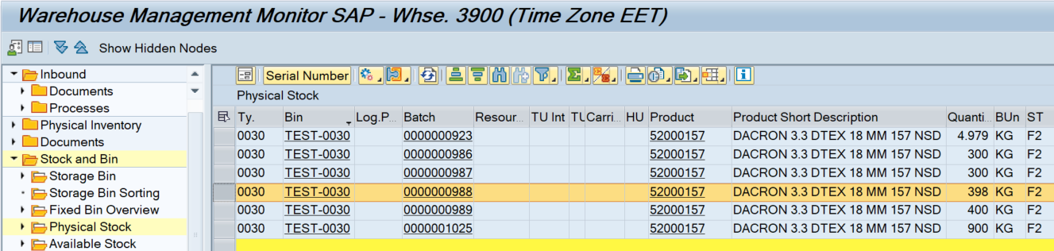

Click on Product / Batch button and enter Source Bin and Product.

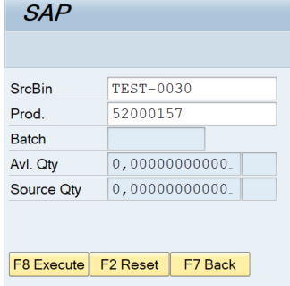

Press Enter to check if the product is batch managed then Batch field will change as input field.

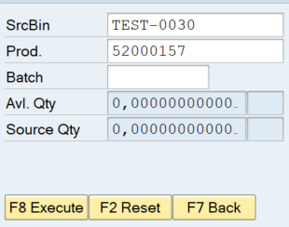

Input batch and press enter

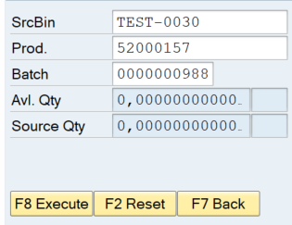

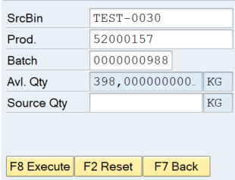

Now input the source quantity and press execute button to create the warehouse task for final bin movement

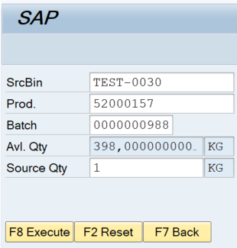

Same as SAP standard behavior, screen flow will come back to initial menu if successful.

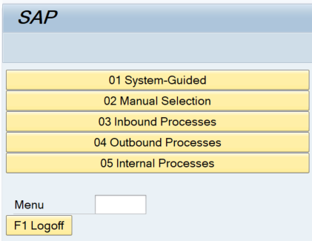

After Quantity:

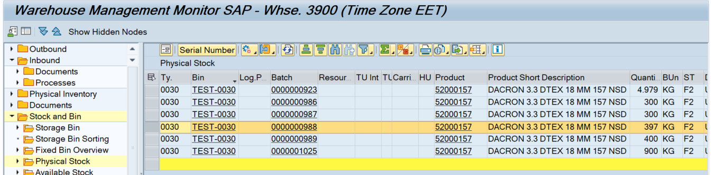

Go to /SCWM/MON transaction code and check the warehouse task for the movement to final bin.

